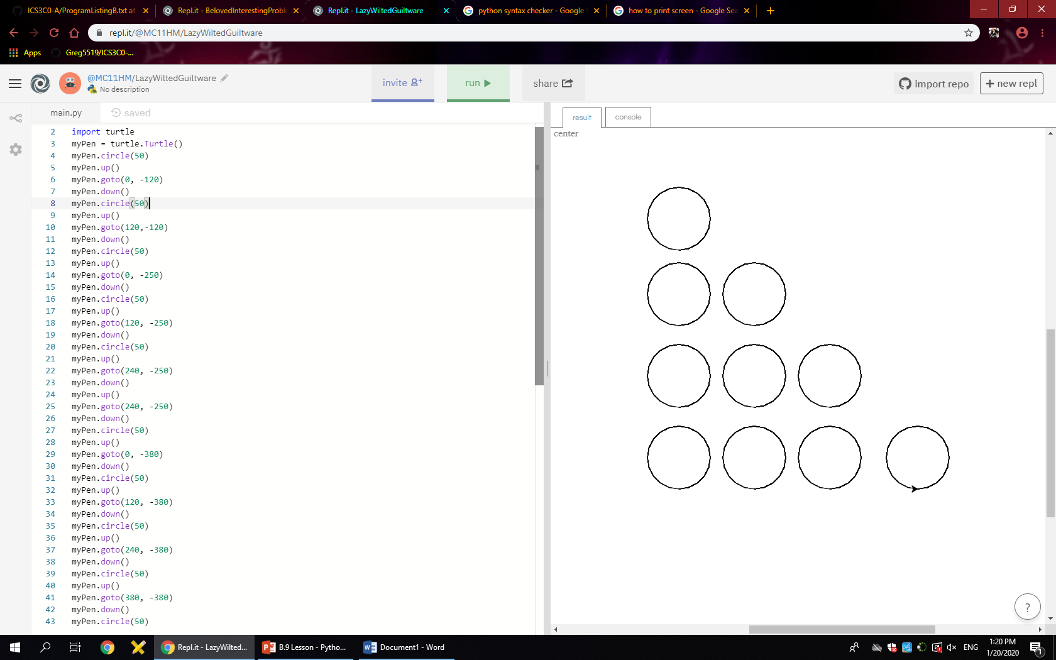

import turtle

myPen = turtle.Turtle()

myPen.circle(50)

myPen.up()

myPen.goto(0, -120)

myPen.down()

myPen.circle(50)

myPen.up()

myPen.goto(120,-120)

myPen.down()

myPen.circle(50)

myPen.up()

myPen.goto(0, -250)

myPen.down()

myPen.circle(50)

myPen.up()

myPen.goto(120, -250)

myPen.down()

myPen.circle(50)

myPen.up()

myPen.goto(240, -250)

myPen.down()

myPen.up()

myPen.goto(240, -250)

myPen.down()

myPen.circle(50)

myPen.up()

myPen.goto(0, -380)

myPen.down()

myPen.circle(50)

myPen.up()

myPen.goto(120, -380)

myPen.down()

myPen.circle(50)

myPen.up()

myPen.goto(240, -380)

myPen.down()

myPen.circle(50)

myPen.up()

myPen.goto(380, -380)

myPen.down()

myPen.circle(50)